Types of Maintenance Testing - Retest (confirmation), Regression and Impact Analysis

Retesting (Confirmation Testing)
# Source: AI Source: Provided by: [Data Path: Persons Table -> ID Column: 1, Name_En Column: Motasem Essam] -> From: [Chatgpt (GPT‑5 Mini)] on [8/21/2025]
- Meaning: Testing a specific defect again after it has been fixed.
- Goal: Confirm that the exact reported bug is now resolved.
- Scope: Narrow — only the failed test case(s) are executed again.
- When: Immediately after a developer claims to have fixed the defect.
- Example:
  - Bug: “Login fails with correct credentials.”
  - Fix: Developer updates the login function.
  - Retest: Tester runs the same login test case again to confirm it works now.

Regression Testing
# Source: AI Source: Provided by: [Data Path: Persons Table -> ID Column: 1, Name_En Column: Motasem Essam] -> From: [Chatgpt (GPT‑5 Mini)] on [8/21/2025]
- Meaning: Testing unchanged parts of the software to ensure that recent changes didn’t break existing functionality.
- Goal: Catch side effects of code changes.
- Scope: Wide — includes previously working features across the application.
- When: After any change — bug fix, update, or new feature — before release.
- Example:
  - After fixing the login bug, testers also check signup, password reset, dashboard, and profile features to ensure they still work.

Impact Analysis
# Source: AI Source: Provided by: [Data Path: Persons Table -> ID Column: 1, Name_En Column: Motasem Essam] -> From: [Chatgpt (GPT‑5 Mini)] on [8/21/2025]
- Meaning: Identifying which parts of the system may be affected by a code change or bug fix.

- Goal: Focus testing effort on affected areas to ensure changes do not introduce new defects.

- Scope: Variable — can range from a few modules to large parts of the application, depending on the change.

- When: Before testing a change, update, or bug fix to plan effective test coverage.

- Example:
After upgrading a database schema, testers identify that reports, queries, and forms may be affected and focus testing on these modules.

Key Difference Table
# Source: AI Source: Provided by: [Data Path: Persons Table -> ID Column: 1, Name_En Column: Motasem Essam] -> From: [Chatgpt (GPT‑5 Mini)] on [8/21/2025]
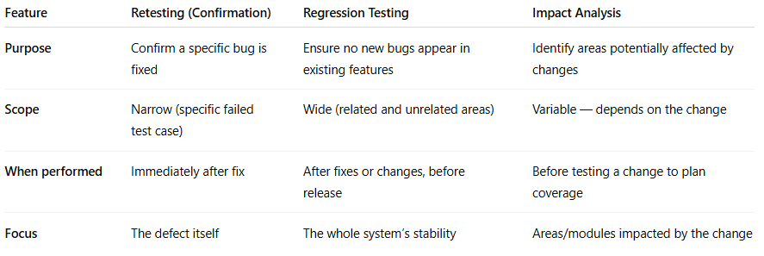

Feature | Retesting (Confirmation) | Regression Testing | Impact Analysis
Purpose | Confirm a specific bug is fixed | Ensure no new bugs appear in existing features | Identify areas potentially affected by changes
Scope | Narrow (specific failed test case) | Wide (related and unrelated areas) | Variable — depends on the change
When performed | Immediately after fix | After fixes or changes, before release | Before testing a change to plan coverage
Focus | The defect itself | The whole system’s stability | Areas/modules impacted by the change

